Group Leadership Pathway

Introduction

The continued growth in the number of groups at Church @ The Springs has created an ongoing need for new leaders to start new groups and for coaches to further develop these leaders and ensure campus consistency.

The following is an executive summary highlighting the growth steps involved with moving from being a group member to leading a small group and then coaching the group leaders.

The Pathway

Group members can be either new to small groups or new to studying the Bible, or are experienced with groups and may have led groups at another church.

The group leadership path progression depends on an individual’s spiritual maturity, growth, and leadership readiness.

People advancing in group leadership at Church @ The Springs will be members in good standing. They will have demonstrated Spiritual gifts in one or more of these areas: administration, hospitality, encouragement, pastoring/shepherding, teaching, serving, mercy, and evangelism.

The following illustration provides a visual representation of a possible leadership development path. The identified specific roles are defined in this document to assist with a basic understanding of the pathway. All steps are required; however, exceptions can be considered by the church staff on a case-by-case basis.

Separate documentation defining the requirements, expectations, and guidelines are available for each identified role.

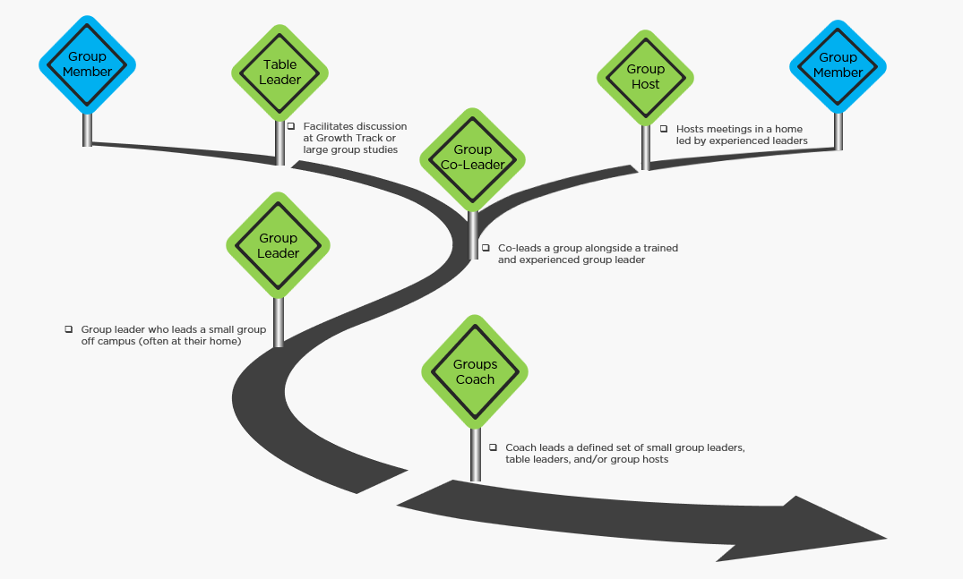

Group Leadership Pathway

Descriptions

1. Group Member

Anyone who attends, or participates in a small or large group. Participants include members and non-members of Church @ The Springs.

2. Table Leaders

Table leaders for Growth Track events and large group studies that occur on campus with approved member(s) or staff present.

To move towards hosting and/or leading a small group, a table leader will:

* + be intentional about completing Growth Track
  + participate in assigned group leader training
  + be proven to be competent and spiritually mature
  + seek approval to be a group leader from the group coordinator, or campus director/pastor

3. Group Host

Group hosts typically welcome 8 to 12 people into their homes for a group study. They provide a comfortable and safe environment for the group meeting. Their hospitality helps the experienced group leader lead the group.

To move towards leading a table or a small group, a group host will:

* + be intentional about completing Growth Track
  + participate in assigned group leader training
  + encourage all group members to complete Growth Track
  + assist the leader with group administration, invite people to join the group, pray for the needs of members and the church, and care for group members.
  + consider co-leading a group in the future
  + be recommended for group leadership by the group coordinator, other approved leaders, or the campus director/pastor

4. Group Co-Leader

Group co-leaders come alongside an experienced leader to lead a group of 8 - 12 people. The leader's role is to prepare the co-leader to lead the group (or another group) in a mutually agreed-upon time frame.

To move towards leading a small group leader, a co-leader will:

* + be intentional about completing Growth Track
  + participate in assigned group leader training
  + encourage all group members to complete Growth Track
  + implement the four pillars of group life in their personal life
  + be willing to assist the leader with all aspects of group life and assume increased leadership responsibilities.
  + demonstrate their ability to successfully lead a group
  + be recommended for group leadership by the group coordinator, other approved leaders, or the campus director/pastor

5. Group Leader

Group leaders can lead a group in their home if they have demonstrated positive experience in small group leadership at The Springs or another church.

Group leaders lead a group of 8 to 12 people in their own home (or another setting). The leader involves the group members in some area of group responsibility. The leader identifies a group member to assist them with group administration and strives to prepare them to lead a group or table on campus.

To move towards becoming a group coach a group leader will:

* + encourage all group members to complete Growth Track
  + implement the four pillars of group life in their own lives
  + complete assigned group leader training
  + be proven at launching other groups
  + be proven at helping other group leaders and have the desire to coach
  + be recommended by a coach, group coordinator, or campus director/pastor.

6. Groups Coach

Group coaches are approved by the campus director/pastor and lead, care for, pray with, disciple, and develop a defined small number of group leaders (2 to 5) and will have personally previously served as a group leader at The Springs for more than 1 year. They recognize that their role as a coach and their relationships with their assigned small group leaders are a priority despite the rigors of normal church involvement.

Coaches will touch base with group leaders once per month to answer questions, keep them informed of upcoming training or classes, coach them in areas where they have identified needs, and attend the group meeting of their coach’s leaders occasionally.

Coaches are actively involved with the group ministry at Church @ The Springs and as a minimum, this means continuing to lead or co-lead a group.